TABLE OF CONTENTS
1. INTRODUCTION..................................................................................................................3
1.1 Project Overview...............................................................................................................3
1.2 Project Objectives and Key Research Questions.................................................................3
2. DATA SOURCES....................................................................................................................4
2.1 Tools Used for the Analysis................................................................................................4
2.2 Description of the Data......................................................................................................4
2.3 Data Ethics and Confidentiality..........................................................................................6
3. DATA CLEANING AND TRANSFORMATION............................................................................6
3.1 Handling Missing Values....................................................................................................7
3.2 Data Type Conversion and Standardization........................................................................7
3.3 Data Transformation for Analytical Readiness....................................................................8
4. DESCRIPTIVE ANALYSIS AND VISUAL INSIGHTS.....................................................................8
4.1 Average Salary within the Organisation..............................................................................9
4.1.1 Strategic Priority: Human Resources Leads the Salary Structure.................................10
4.1.2 Technical and Creative Drivers: Information Technology and Marketing.....................10
4.1.3 Mid-Level Compensation: Finance and Engineering...................................................10
4.1.4 Operational and Support Level Departments............................................................11
4.1.5 Overall Insight: A Clearly Tiered Compensation System............................................11
4.2 AGE DISTRIBUTION AMONG EMPLOYEES........................................................................12
4.2.1 Predominance of a Young Workforce (Ages 25–32) .................................................13
4.2.2 Emerging Mid-Career Segment (Ages 33–45) ..........................................................13
4.2.3 Reduced Representation of Senior Professionals (Ages 46–55) ...............................13
4.2.4 Limited Presence of Older Employees (Ages 56–65) ...............................................13
4.2.5 Overall Workforce Age Structure.............................................................................14
4.3 MARITAL STATUS (WIDOWED) DISTRIBUTION ACROSS DEPARTMENTS..........................14
4.3.1 Even Distribution Across Departments...................................................................15
4.3.2 Higher Concentration in Corporate and Strategic Departments.............................15
4.3.3 Moderate Representation in Technical and Operational Departments....................16
4.3.4 Lower Concentration in Administrative and Support Functions...............................16
4.3.5 Overall Insight: Inclusive Workforce Composition.................................................16
4.4 IMPACT OF EDUCATION LEVEL ON EMPLOYEE SALARY................................................17
4.4.1 Earnings Gap Across Degree Levels.......................................................................18
4.4.2 Premium Tier: Advanced and Specialized Degrees...............................................18
4.4.3 Mid-Tier: Master’s Degrees................................................................................19
4.4.4 Undergraduate Tier...............................................................................................19
4.4.5 Overall Insight: Education as a Strategic Lever.........................................................19
4.5 EMPLOYEE DISTRIBUTION BY STATE OF ORIGIN..............................................................20
4.5.1 Dominance of the South-East....................................................................................21
4.5.2 Moderate Representation from the South-West........................................................22
4.5.3 Notable Northern Participation...............................................................................22
4.5.4 Regional Imbalance and Implications......................................................................23
4.5.5 Overall Interpretation..............................................................................................23
5. INFERENTIAL AND STATISTICAL ANALYSIS.........................................................................24
5.1 Gender-Based Salary Disparities (Independent Samples T-Test) ......................................24
5.1.1 Understanding the Hypotheses.................................................................................25
5.1.2 Key Metric: The P-Value............................................................................................25
5.1.3 Key Metric: The T-Statistic.........................................................................................25
5.2 DEPARTMENTAL SALARY COMPARISONS (ONE-WAY ANOVA) ..........................................26
5.2.1 Understanding the Hypotheses..................................................................................26
5.2.2 Key Metric: The P-Value...........................................................................................27
5.2.3 Key Metric: The F-Statistic ........................................................................................27
5.3 RELATIONSHIP BETWEEN MARITAL STATUS AND DEPARTMENT ALLOCATION...................27
5.3.1 Understanding the Hypotheses..................................................................................28
5.3.2 Key metric.................................................................................................................28
6. SUMMARY INSIGHTS..........................................................................................................29
7. RECOMMENDATIONS.........................................................................................................30
8. CONCLUSION.....................................................................................................................31

1. INTRODUCTION
1.1 Project Overview
This project, titled “Employee Demographic and Compensation Analysis for Elite Bank Limited,” investigates the demographic characteristics and salary structure of the organization’s workforce using quantitative data analytics techniques. The study adopts both descriptive and inferential statistical approaches to uncover patterns in employee distribution, pay equity, and organizational diversity.
The analysis is motivated by the increasing importance of data driven human resource management, where workforce decisions are guided by evidence rather than intuition. Through the systematic evaluation of employee attributes such as gender, age, education level, department, marital status, and state of origin this project provides insight into the structure and equity of compensation within the organization.
Ultimately, the research seeks to inform strategic HR practices in recruitment, promotion, and retention by identifying relationships between demographic factors and compensation outcomes. By analyzing the Elite Bank employee dataset, the study also demonstrates how data analytics can serve as a practical decision tool for improving fairness, efficiency, and organizational sustainability.
1.2 Project Objectives and Key Questions
The overarching aim of this study is to explore how demographic and structural characteristics influence compensation patterns at Elite Bank Limited. Specifically, the objectives are to:
- Map Workforce Demographics: Examine the composition of the workforce across age, gender, marital status, and state of origin to identify trends and diversity patterns.
- Analyze Compensation Equity: Evaluate whether salaries are distributed equitably across gender and departmental lines.
- Assess Structural Relationships: Determine how education level and departmental affiliation affect compensation outcomes.
- Generate Strategic Insights: Translate statistical findings into actionable recommendations for human resource and organizational policy improvement.
From these objectives, the following key research questions were developed:
- Which department offers the highest average salary?
- What is the age distribution of employees within the organization?
- Are widowed employees more prevalent in particular departments?
- Does higher educational attainment correspond to higher salaries?
- Which states contribute the largest proportion of employees to the workforce?
The answers to these questions are obtained through a combination of data cleaning, visualization, and statistical hypothesis testing conducted using Python-based analysis tools.
2. DATA SOURCES
2.1 Tools Used for the Analysis
This study employed an integrated suite of data management and statistical analysis tools to ensure accuracy, reproducibility, and analytical depth. The analysis was conducted primarily using Python programming language within a Jupyter Notebook environment. This platform was selected for its flexibility, reproducibility, and seamless integration of statistical computation with data visualization.
The following Python libraries were utilized:
- Pandas: for data manipulation, cleaning, and summarization;
- NumPy: for numerical and array-based computations;
- Matplotlib and Seaborn: for producing clear and insightful visualizations;
- SciPy and Statsmodels: for conducting inferential statistical tests such as T-tests, ANOVA, and Chi-square analyses.
Additionally, data retrieval and management were supported by PostgreSQL, which served as the primary database system from which the dataset was obtained. The combination of these tools provided an efficient workflow for cleaning, exploring, and statistically interpreting the dataset.
2.2 Description of the Data
The dataset analyzed in this study "elitebank_db.csv" was obtained from the Alven Postgres Server and contains detailed information on the employees of Elite Bank Limited. The data include demographic, professional, and compensation related attributes that together provide a comprehensive view of the organization’s workforce composition.
The key variables are summarized as follows:
The dataset used for the Elite Bank Employee Demographic and Compensation Analysis contains several key variables that describe both the personal and professional characteristics of employees.
1. employee_id
This is a unique identifier assigned to every employee within the organization. It ensures that each record in the dataset can be distinctly recognized and referenced without confusion.
2. name
This column contains the full name of each employee. While it provides identity context, it is typically excluded or anonymized during analysis to ensure privacy and compliance with data protection policies.
3. gender
Indicates the sex of the employee, categorized as either Male or Female. This variable is crucial for gender-based analysis such as identifying potential salary disparities.
4. age
Represents the age of the employee in years. It helps in analysing age distribution, identifying workforce demographics, and understanding the relationship between employee experience and compensation levels.
5. department
Specifies the organizational department to which the employee belongs (e.g., Finance, Marketing, IT, Human Resources).
6. job_title
Refers to the designation or position held by the employee (e.g., Analyst, Manager, Executive). It reflects the employee’s rank or level within the organization and is often a key determinant of salary.
7. salary
Represents the monthly or annual remuneration received by each employee.
8. hire_date
The date on which the employee was hired by Elite Bank.
9. state_of_origin
Shows the geographical state where the employee originates from. This information supports analysis of geographical diversity and inclusion within the workforce, highlighting whether the organization employs people from various regions.
10. phone_number
Contains the contact phone number of the employee. While important for HR records, this field is typically not used in data analysis but can be retained for verification or internal administrative purposes.
11. marital_status
Indicates the marital status of each employee (e.g., Single, Married, Widowed, Divorced).
12. education_level
Represents the highest level of academic qualification attained by the employee (e.g., Diploma, Bachelor’s, Master’s, PhD).
Certain personally identifiable variables such as name and phone_number were excluded from the analytical process to protect privacy and ensure ethical data handling.
2.3 Data Ethics and Confidentiality
All analyses were conducted with strict adherence to data protection and ethical standards. Employee information was anonymized prior to processing, ensuring compliance with privacy and confidentiality regulations. The dataset was used exclusively for analytical and educational purposes, with no personal identifiers disclosed in any form.
3. DATA CLEANING AND TRANSFORMATION
Data cleaning and transformation are essential preparatory stages in any quantitative research process. Before conducting any form of statistical or visual analysis, it is critical to ensure that the dataset is accurate, consistent, and free of anomalies that could bias results or mislead interpretation.
For this project, several data preprocessing steps were undertaken to enhance the integrity of the Elite Bank Employee Dataset. The primary objectives were to identify and handle missing values, standardize data formats, and prepare the dataset for reliable descriptive and inferential analysis.

3.1 Handling Missing Values
Missing or incomplete data entries were detected in variables such as salary, education_level, and marital_status. To prevent analytical distortion, the following strategies were applied:
- Quantification of Missingness:
The percentage of missing data was computed for each column to assess whether the extent of missingness warranted deletion or imputation.
- Selective Imputation:
  - For numerical variables such as salary, missing values were imputed using the mean or median, depending on the presence of skewness.
  - For categorical variables such as education_level and marital_status, the mode was used for imputation to maintain data integrity without altering distributional balance.
- Row Removal (Listwise Deletion):
In instances where multiple fields were missing for a single employee record, the entire row was excluded to avoid introducing unreliable data into the analysis.
Through these processes, the dataset was rendered complete and analytically robust, ensuring that subsequent statistical tests were based on valid and consistent observations.
3.2 Data Type Conversion and Standardization
To facilitate accurate analysis, data types were systematically reviewed and converted to appropriate formats:
- Date Conversion: The variable hire_date was converted from string to datetime format to enable tenure-based calculations.
- Categorical Encoding: Variables such as gender, department, marital_status, and education_level were converted into categorical types, enabling grouped aggregation and statistical testing.
- Numeric Normalization: Outliers within the salary and age fields were examined using interquartile range (IQR) analysis. Extreme anomalies were adjusted to the nearest acceptable limit or removed if they were proven to be data entry errors.
All numeric variables were further standardized where necessary to support inferential procedures such as ANOVA and T-tests, which assume comparable variance across groups.

3.3 Data Transformation for Analytical Readiness
Following cleaning and standardization, the data were transformed to create new derived variables that would enhance the analytical process. For instance:
Following data cleaning and type standardization, certain variables were transformed to enhance interpretability and support visualization. For example, departmental salary averages and education level summaries were computed to compare compensation structures across organizational units.
However, the age variable was maintained in its continuous numerical form rather than grouped into discrete categories. This approach allowed for more precise analysis of age salary relationships and visualization of employee age distribution using histograms.
Categorical variables such as gender, marital_status, and education_level were standardized to ensure consistent grouping during aggregation and statistical testing.
The final cleaned and transformed dataset was verified for consistency, accuracy, and completeness before moving on to descriptive analysis and visualization.
4. DESCRIPTIVE ANALYSIS AND VISUAL INSIGHTS
Descriptive analysis provides a fundamental understanding of the dataset’s structure and central tendencies before engaging in deeper inferential tests. It involves summarizing employee characteristics, compensation levels, and distribution patterns across departments, age groups, education levels, and states of origin.
This stage of the research employed statistical summaries, frequency distributions, and visual representations generated through Python libraries such as Matplotlib and Seaborn. The goal was to present a clear, data-driven overview of Elite Bank’s workforce composition and compensation dynamics.

4.1 Average Salary within the Organisation

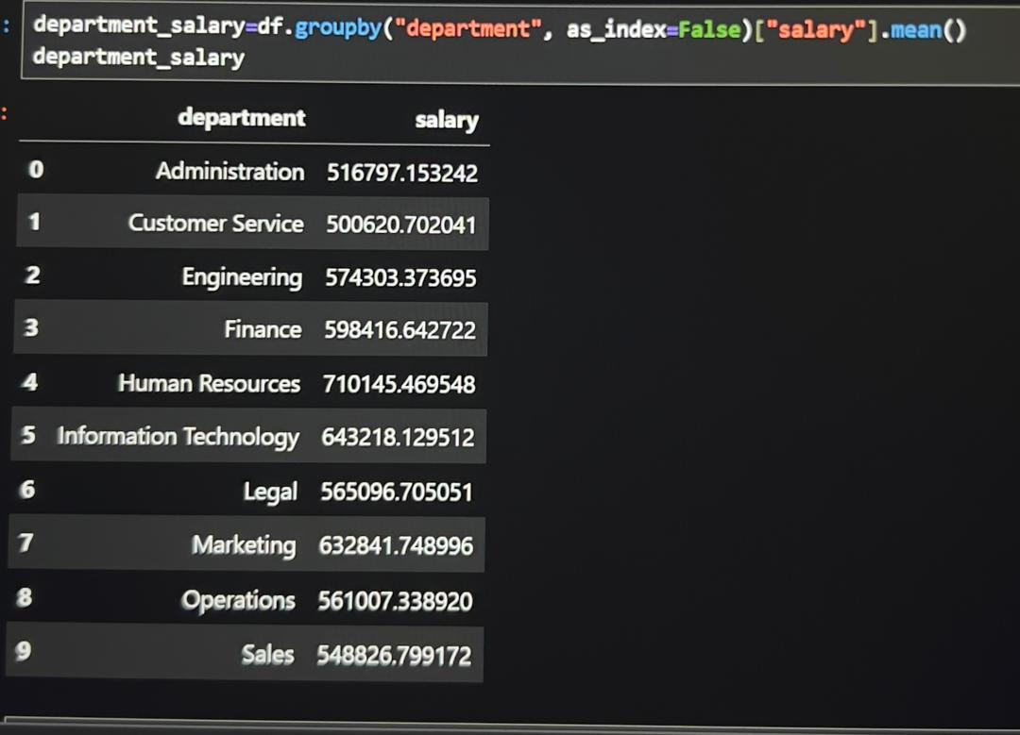

Fig4.1A Table showing the average salary across the 10 departments within the organization.

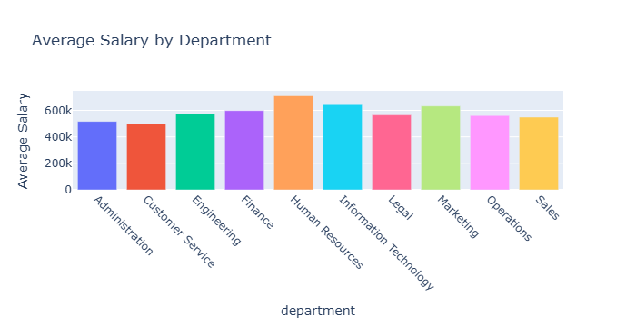
Fig4.1B Bar chart showing Average Salary by Department

4.1.1 Strategic Priority: Human Resources Leads the Salary Structure
Observation:
The Human Resources (HR) department records the highest mean salary at ₦710,000, placing it firmly at the top of the organisation’s compensation hierarchy.
Implication:
• This highlights HR’s strategic importance in workforce management, policy development, and organisational culture.
• The elevated compensation suggests that HR professionals occupy influential roles requiring advanced expertise in talent management and organisational planning.
• It indicates that the organisation prioritises employee engagement, leadership development, and compliance, areas typically overseen by HR.
• The higher salary level may also function as a retention strategy for senior HR specialists whose roles directly affect overall productivity and staff performance.

4.1.2. Technical and Creative Drivers: Information Technology and Marketing
Observation:
The Information Technology (IT) department follows with an average salary of ₦640,000 while Marketing ranks next at ₦630,000.
Implication:
• IT’s strong ranking reflects the organisation’s reliance on digital tools, security systems, software development, and technological infrastructure.
• High technical compensation suggests that the organisation values innovation, cybersecurity, and system reliability to maintain operational efficiency.
• Marketing’s competitive pay level indicates its role in customer acquisition, brand visibility, and strategic communication.
• The investment in marketing suggests a strong emphasis on digital outreach, market positioning, and customer loyalty in a competitive environment
4.1.3. Mid-Level Compensation: Finance and Engineering
Observation:
The Finance department averages ₦590,000, while Engineering follows with ₦570,000.
Implication:
• These departments represent core operational and analytical functions within the organisation.
• Finance plays a critical role in financial planning, auditing, budgeting, and risk analysis responsibilities requiring precision and accountability.
• Engineering’s salary level suggests a mix of technical and operational responsibilities, combining both problem-solving and maintenance-related tasks.
• The moderate salaries indicate a balanced staff mix, with both experienced professionals and entry-to-mid level employees contributing to overall performance.
4.1.4. Operational and Support Level Departments
Observation:
The Legal and Operations departments both have a mean salary of ₦560,000, followed by Sales at ₦540,000, Administration at ₦510,000, and Customer Service at ₦500,000 the lowest across all departments.
Implication:
• These departments typically handle routine, process-driven, and customer facing tasks necessary for day-to-day organisational functioning.
• Legal and Operations show moderate salaries, reflecting structured roles focused on compliance, coordination, and workflow optimisation.
• Sales roles rely heavily on performance metrics and customer acquisition but often include a large proportion of entry-level staff, which lowers the average salary.
• Administration and Customer Service roles are generally standardised and volume-based, with compensation reflecting the operational nature of the work.
• Lower salaries at the support level may require additional incentives or development opportunities to maintain employee motivation and reduce turnover.
4.1.5. Overall Insight: A Clearly Tiered Compensation System
Observation:
The salary distribution reveals a distinct three-tier compensation structure, with HR, IT, and Marketing forming the high-income tier, Finance and Engineering in the mid-tier, and operational/support departments in the lower tier.
Implication:
• This compensation pattern shows that the organisation prioritises strategic, technical, and leadership-oriented functions.
• The difference between the highest and lowest departmental averages (₦710,000 vs ₦500,000) indicates a ₦210,000 pay gap, reflecting differentiated value attribution across roles.
• Such a structure may enhance efficiency but requires careful management to avoid perceptions of inequity among lower-tier employees.
• Introducing performance-based bonuses, training programs, and upward mobility pathways could help balance long-term staff satisfaction and fairness.
Overall, the compensation strategy aligns with productivity, innovation, and organisational impact while maintaining cost control in administrative and customer-facing roles.

4.2 Age Distribution among Employees
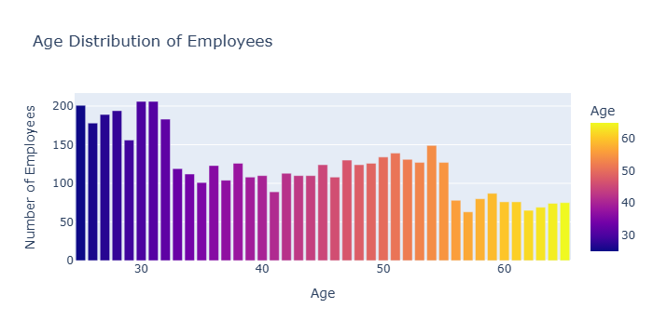
Fig4.2A Bar chart showing Age Distribution of Employees

Interpretation of Findings (Age Distribution)

4.2.1. Predominance of a Young Workforce (Ages 25–32)
Observation:
The largest proportion of employees falls within the age range of 25 to 32 years, with individual age counts between 178 and 206 employees. This clearly indicates that Elite Bank’s workforce is dominated by young professionals in their early and mid career stages.
Implication:
This youthful demographic reflects a dynamic and adaptable workforce capable of learning new systems and adapting quickly to technological innovations. It also suggests active recruitment of younger staff, possibly due to the growing need for digital skills and operational efficiency. However, the organization must also ensure that these young employees receive adequate mentorship, training, and career development support to retain them and prevent high turnover rates common among early-career workers.

4.2.2. Emerging Mid-Career Segment (Ages 33–45)
Observation:
The number of employees within the 33–45 age bracket begins to decline noticeably, with counts ranging between 101 and 124 employees for most ages.
Implication:
This suggests that the mid-career workforce is relatively underrepresented compared to the younger age groups. The decline may point to historical gaps in recruitment or higher attrition rates among mid-level professionals, who are often targeted by competing financial institutions for managerial and technical roles. The limited presence of this age group may also indicate a transitional phase in Elite Bank’s workforce structure, emphasizing the need to strengthen retention strategies for mid career employees who hold valuable institutional experience.
4.2.3. Reduced Representation of Senior Professionals (Ages 46–55)
Observation:
Employee numbers within the 46–55 age range continue to decrease steadily, averaging around 108–139 individuals per age group.
Implication:
This pattern reflects a smaller population of experienced senior staff. While this may create opportunities for younger employees to advance into leadership roles, it also highlights a potential risk of knowledge gaps and reduced mentorship capacity. Elite Bank may need to implement structured knowledge transfer programs and succession planning to preserve institutional wisdom as senior employees approach retirement age.
4.2.4. Limited Presence of Older Employees (Ages 56–65)
Observation:
The workforce beyond 56 years of age comprises the smallest segment, with employee counts dropping to as low as 63 by age 57 and remaining below 80 up to age 65.
Implication:
This demonstrates that only a small proportion of staff continue employment close to or beyond the typical retirement age. While this suggests a youthful organizational culture and possible adherence to age-based retirement policies, it may also indicate early exits due to workload, lack of flexible work arrangements, or limited senior consultancy roles. Elite Bank could benefit from leveraging this group’s expertise through mentorship, training roles, or short term consultancy contracts before their eventual retirement.
4.2.5. Overall Workforce Age Structure: Youth-Dominated but Transitional
Observation:
Overall, the bank’s workforce displays a strong youthful base with a gradual tapering as age increases. The distribution curve peaks between ages 25–32 and declines steadily thereafter, forming a youthful pyramid structure.
Implication:
This age profile reveals a developing organization focused on long term sustainability through youth recruitment. However, the declining middle and senior age segments highlight a transitional workforce structure that requires deliberate succession planning, mentorship frameworks, and balanced recruitment policies. Maintaining a healthy mix of youth and experience will ensure both innovation and stability in the bank’s future human capital composition.
4.3 Marital Status (Widowed) Distribution Across Departments

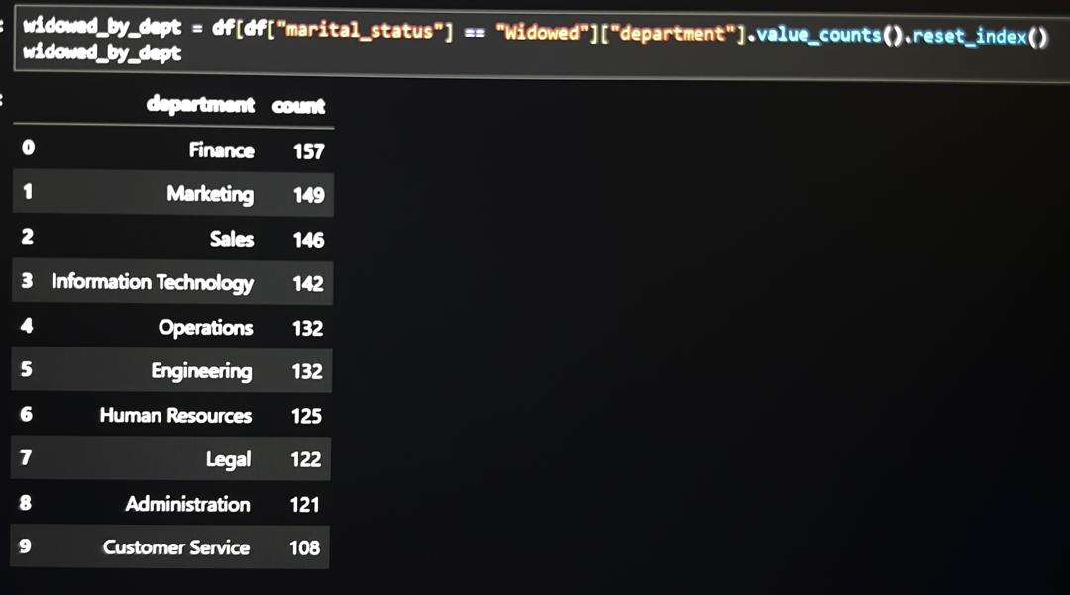
4.3A Table showing the Distribution of Widowed Employee across Departments

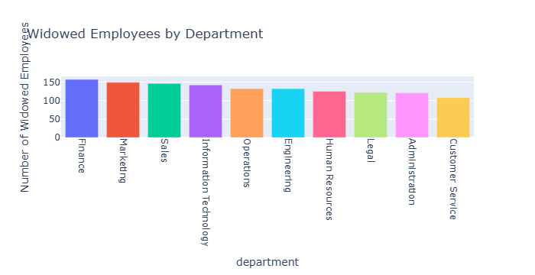
Figure 4.3B Bar chart showing the Distribution of Widowed Employee across Departments
4.3.1. Detailed Insights & Observations (Widowed Employees)
1. Remarkably Even Distribution Across Departments
Observation:
The distribution of widowed employees across departments shows minimal variation, with Finance having the highest number (157) and Customer Service the lowest (108). The difference between the two extremes is only 49 employees, and most departments fall within a narrow range of 120–150 individuals.
Implication:
This indicates a consistent representation across all functional areas, demonstrating that widowhood is not concentrated in any particular department. The even spread suggests that marital status does not influence departmental placement or job roles within the bank. As such, company-wide welfare measures such as bereavement leave, emotional support programs, or counselling services would be more effective than department-specific interventions.

4.3.2. Higher Concentration in Corporate and Strategic Departments
Observation:
Corporate-oriented departments such as Finance (157), Marketing (149), and Sales (146) recorded the highest numbers of widowed employees.
Implication:
These departments typically employ experienced professionals and senior staff who may have spent longer tenures in their careers, correlating naturally with a higher probability of widowhood. Their higher counts could therefore reflect age and professional maturity rather than any occupational influence. This also suggests that strategic and client-facing departments may host older, more stable employees who bring institutional experience and relationship management skills to the bank.

4.3.3. Moderate Representation in Technical and Operational Departments
Observation:
The Information Technology (142) and Operations (132) departments occupy the mid-range of the distribution.
Implication:
This balance implies that technical and process oriented roles maintain a proportional demographic mix, combining both younger and older professionals. It suggests that these departments have a diverse workforce, possibly due to continuous recruitment cycles and evolving technological needs. The moderate counts align with the overall workforce trend, confirming that widowhood is not significantly associated with any specific functional category.

4.3.4. Lower Concentration in Administrative and Support Functions
Observation:
The Human Resources (125), Legal (122), Administration (121), and Customer Service (108) departments recorded the lowest representation of widowed employees.
Implication:
These departments often have a younger or more transient workforce, with shorter average tenures and higher employee turnover. Customer Service, in particular, is often an entry-level domain with limited age diversity, which could explain its relatively low count. The results suggest that departmental composition, rather than policy or bias, accounts for the difference in widowed representation. This trend also reinforces the organization’s broad demographic inclusivity.
4.3.5. Overall Insight: Equitable and Inclusive Workforce Composition
Observation:
The overall distribution reveals a balanced and inclusive demographic profile across the organization, with no single department displaying a disproportionate concentration of widowed employees.
Implication:
This pattern underscores Elite Bank’s equitable employment structure, where personal characteristics such as marital status do not influence departmental distribution or opportunities. The findings reinforce the organization’s commitment to fairness and social sensitivity. To further strengthen inclusion, Elite Bank may consider maintaining organization-wide wellbeing initiatives, bereavement support, and periodic diversity assessments to ensure sustained equity across its human capital structure.

4.4 Impact of Education Level on Employee Salary
Figure 4.4 (Bar chart showing average salary by education level) demonstrates the relationship between educational attainment and salary levels.

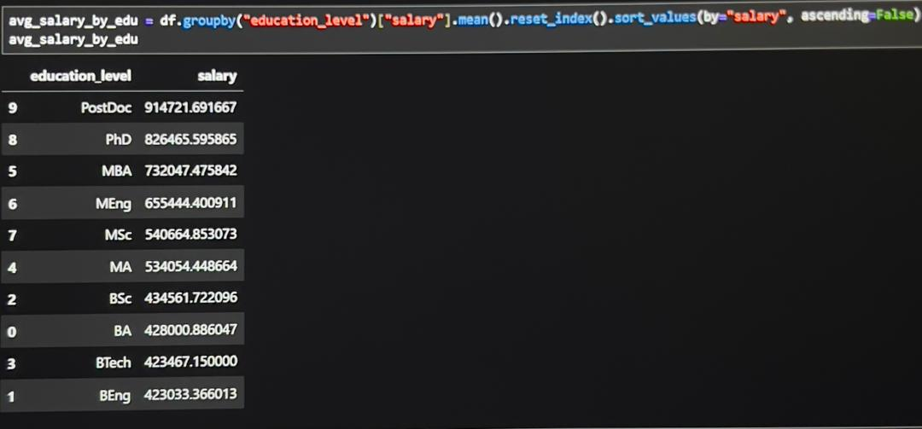
Figure 4.4 Table showing average salary by education level

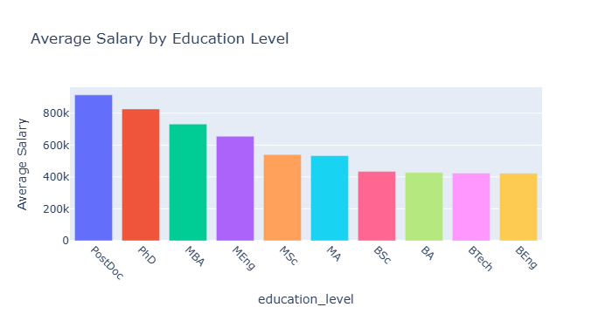
Figure 4.4B Bar chart showing average salary by education level
Detailed Insights & Observations: Impact of Education Level on Employee Salary
4.41. A Stark "Earnings Chasm" Between Degree Levels
- Observation: There is a substantial pay gap between the highest and lowest academic qualifications. Employees with Postdoctoral (PostDoc) qualifications earn an average salary of approximately ₦914,000, while those with Bachelor’s degrees (BSc, BA, BEng, BTech) earn between ₦423,500 and ₦440,300. The difference of over ₦460,000 highlights a strong upward trend in compensation with higher education attainment.
- Implication: This finding confirms that advanced qualifications yield significant financial rewards within Elite Bank. The result reflects an organizational structure that heavily prioritizes expertise, specialized knowledge, and advanced professional competence. It also presents a clear financial incentive for employees to pursue postgraduate studies as a pathway to career and salary advancement.
4.4.2. The Premium Tier: Advanced and Specialized Degrees
- Observation: The highest-earning categories PostDoc (₦914,000), PhD (₦826,000), and MBA (₦732,000) represent the top salary band.
  - PostDoc: Indicates mastery of research and innovation, often associated with strategic or highly technical roles.
  - PhD: Reflects deep specialization and analytical expertise critical for policy, research, or leadership functions.
  - MBA: The highest-paying non doctoral degree, highlighting the value placed on leadership, strategic management, and financial acumen within Elite Bank.
- Implication: The organization equally values both technical expertise and managerial leadership. Advanced research-oriented qualifications (PostDoc, PhD) and executive-focused degrees (MBA) are seen as key contributors to innovation, governance, and long-term organizational performance.
4.4.3. The Mid-Tier: Master’s Degrees
- Observation: The next tier includes MSc (₦540,664), MA (₦534,054), and MEng (₦432,700) holders. Although all fall within the master’s category, there is a clear internal hierarchy technical and science-based fields (MSc, MEng) are paid slightly more than arts based qualifications (MA).
- Implication: This suggests that technical proficiency and applied expertise are rewarded more than generalist or theoretical training at the master’s level. However, the relatively close salary range also indicates a consistent recognition of postgraduate education as a whole, regardless of discipline, for its role in enhancing analytical and managerial capacity.
4.4.4. The Undergraduate Tier: A Flattened Salary Landscape
- Observation: Employees with undergraduate qualifications BSc (₦434,561), BA (₦428,000), BEng (₦633,911), and BTech (₦440,300) occupy the lowest salary category. Apart from the slightly higher BEng salary, the differences between other degree types are marginal, showing minimal impact of discipline on earnings.
- Implication: An undergraduate degree serves as a baseline qualification rather than a differentiator in pay. The uniformity indicates that job roles at this level are largely standardized, with performance and experience likely influencing salary progression more than the specific type of bachelor’s degree.
4.4.5. Overall Insight: Educational Attainment as a Strategic Lever
- Observation: The data reveal a strong positive correlation between education level and salary, with postgraduate and doctoral qualifications commanding significantly higher pay.
- Implication: This underscores Elite Bank’s strategic emphasis on intellectual capital and professional development. The trend supports continuous investment in employee education through tuition assistance, professional certifications, and postgraduate training.
It also reinforces the value of academic advancement as a key driver of both career mobility and compensation growth within the organization.

4.5 Employee Distribution by State of Origin
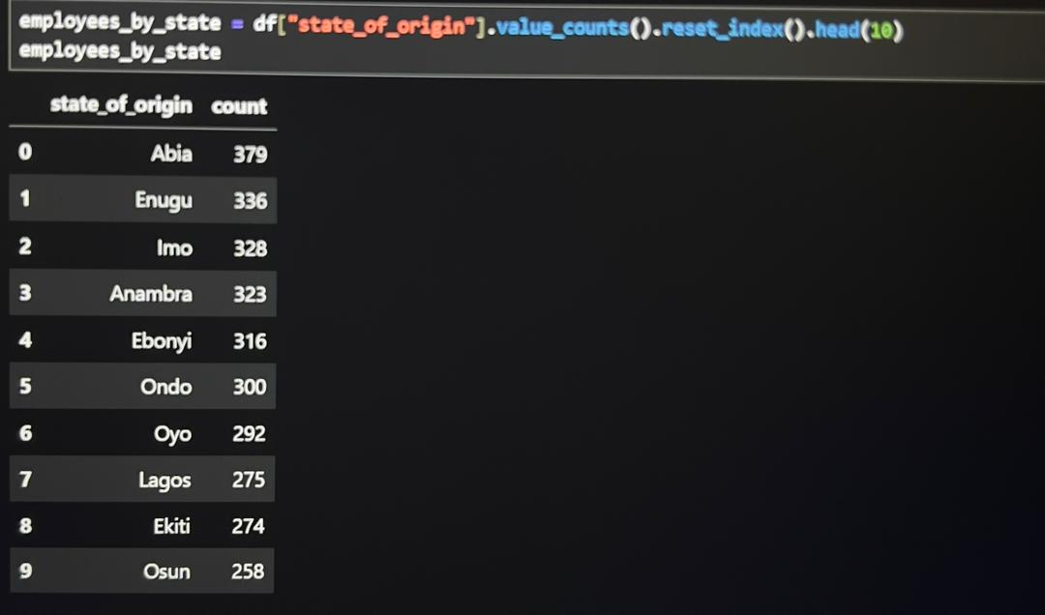


Figure 4.5A Table showing employee count by state of origin

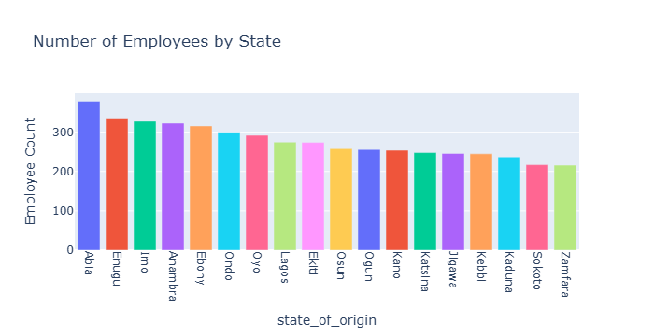

The employee distribution across Nigerian states shows a strong concentration in the South-East geopolitical zone, followed by moderate representation from the South-West and North-West regions (see Figure 4.4B above). These patterns highlight Elite Bank’s current regional workforce footprint and expose potential gaps in nationwide recruitment inclusivity.

Detailed Insights & Observations
4.5.1 Dominance of the South-East Geopolitical Zone
Observation:
The South-East continues to dominate the workforce distribution, led by:
- Abia – 379 (14.6%)
- Enugu – 336 (13.0%)
- Imo – 328 (12.6%)
- Anambra – 323 (12.4%)
- Ebonyi – 316 (12.2%)
Combined, the South-East contributes approximately 64.8% of the total workforce, making it the most represented region.
Implication:
This overwhelming presence indicates that Elite Bank’s recruitment pipeline is heavily concentrated in the South-East. This may stem from historical branch presence, stronger applicant pools, or community-based hiring patterns.
However, reliance on one region can limit national diversity. The bank should consider strategies that broaden recruitment across underrepresented zones.

4.5.2 Moderate Representation from the South-West Zone
Observation:
The South-West shows a stable workforce presence with contributions from:
- Ondo – 300 (11.5%)
- Oyo – 292 (11.3%)
- Lagos – 275 (10.6%)
- Ekiti – 274 (10.6%)
- Osun – 258 (9.9%)
- Ogun – 256 (9.9%)
Together, the South-West accounts for approximately 23.8% of the workforce.
Implication:
The strong numbers from Lagos and surrounding states reflect the region’s role as a commercial hub. Despite this, the gap between the South-West and the highly dominant South-East suggests that Elite Bank’s geographic recruitment spread is still unbalanced.

4.5.3 Notable Northern Participation, Driven by the North-West Zone
Observation:
The North-West shows growing but still moderate workforce participation, led by:
- Kano – 254 (9.8%)
- Jigawa – 246 (9.5%)
- Katsina – 248 (9.6%)
- Kebbi – 245 (9.4%)
- Kaduna – 237 (9.1%)
- Sokoto – 217 (8.3%)
- Zamfara – 216 (8.3%)
Collectively, the North-West contributes about 23.6% of the workforce.
Implication:
Despite being geographically distant from the bank’s strongest recruitment base, the solid representation from Kano, Jigawa, and Katsina suggests emerging recruitment connections in the North-West.
However, the overall northern contribution still trails behind the southern zones, highlighting the need for more proactive outreach in Northern Nigeria.

4.5.4 Regional Imbalance and Strategic Implications
Observation:
The updated employee counts show a significant regional skew: the South-East alone contributes nearly three times the workforce of many Northern states individually, and more than double the contributions of other entire geopolitical zones.
Implication:
Such imbalance may affect organizational diversity, cultural representation, and national service penetration.
To address this, Elite Bank should consider:
- Establishing recruitment centres in underrepresented zones (North-East, North-Central, South-South).
- Partnering with institutions for internship and graduate hiring pipelines.
- Implementing diversity and inclusion recruitment targets.
- Expanding outreach programmes to attract talent across all regions.

4.5.5 Overall Interpretation
The updated distribution confirms that Elite Bank’s workforce is heavily concentrated in the South-East, with the South-West and North-West showing moderate participation.
While these patterns may reflect historical recruitment strengths, they underscore the need for more balanced, nationwide hiring to enhance inclusivity, diversify talent, and strengthen the organization’s national presence.

5. INFERENTIAL AND STATISTICAL ANALYSIS
Inferential statistics were applied to evaluate whether the observed descriptive trends are statistically significant or merely the result of random variation.
Three key tests were conducted:
- An Independent Samples T-test to assess gender-based salary disparities,
- A One-Way ANOVA to compare departmental salary means, and
- A Chi-Square Test of Independence to examine associations between marital status and department allocation.
Each test was performed at a significance level (α) of 0.05, ensuring that any accepted findings were statistically robust.
5.1 Gender-Based Salary Disparities (Independent Samples T-Test)
Hypotheses:
- H₀ (Null Hypothesis): There is no significant difference in the mean salary between male and female employees.
- H₁ (Alternative Hypothesis): There is a significant difference in the mean salary between male and female employees.
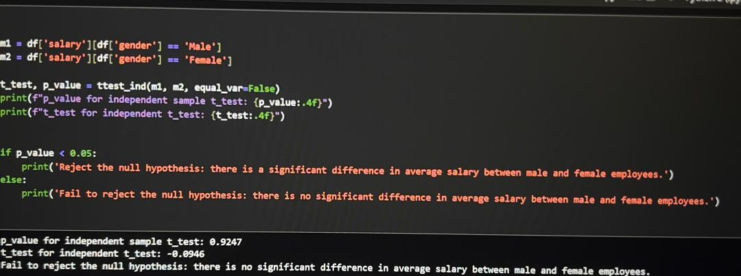
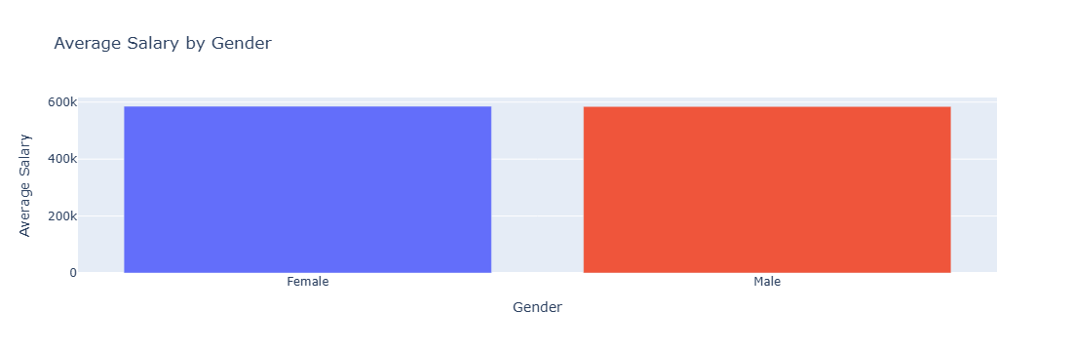
Detailed Interpretation
5.11. Understanding the Hypotheses
- Null Hypothesis (H₀): There is no difference in the average salary between male and female employees. (Mean Male Salary = Mean Female Salary)
- Alternative Hypothesis (H₁): There is a statistically significant difference in the average salary between male and female employees. (Mean Male Salary ≠ Mean Female Salary)
5.1.2. Key Metric: The P-Value (p_val = 0.9247)
- What it is: The p-value is the probability of obtaining the observed results (or more extreme results) if the null hypothesis is true. In simpler terms, it tells us how likely we are to see this data if there was actually no real salary difference.
- The Interpretation: A p-value of 0.9247means that if there were no true salary difference between genders, we would see a difference as large as (or larger than) the one in this dataset 92.47% of the time purely by random chance.
Conclusion from P-Value: We fail to reject the null hypothesis. The data does not provide sufficient evidence to conclude that a gender pay gap exists in this company.
5.1.3. Key Metric: The T-Statistic (t_stat = -0.0946)
- What it is: The t-statistic measures the size of the difference between the two groups relative to the variation in the data.
- The Interpretation:
  - The sign (negative) indicates that the first group listed (Male) has a slightly lower average salary than the second group (Female) in this specific sample. However, this difference is negligible.
  - The magnitude (0.0946) is extremely close to zero. A t-statistic of zero would mean the group averages are identical. A value of -0.0946 indicates a trivially small difference..
5.2 DEPARTMENTAL SALARY COMPARISONS (ONE-WAY ANOVA)
Hypotheses:
- H₀: All departments have equal mean salaries.
- H₁: At least one department has a significantly different mean salary.
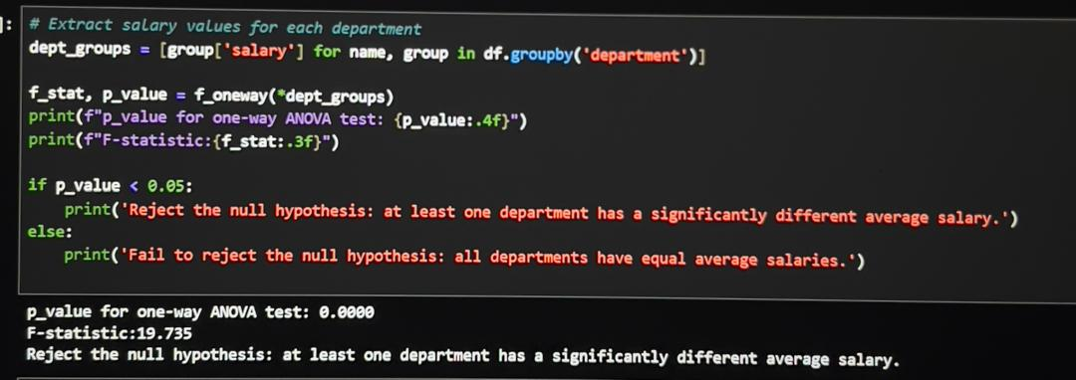

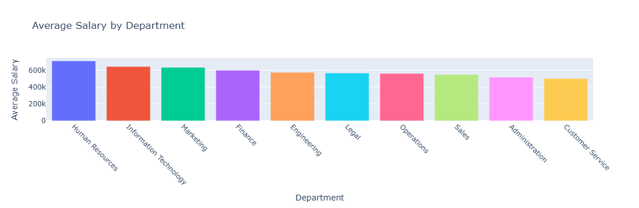
Detailed Interpretation
5.2.1. Understanding the Hypotheses
- Null Hypothesis (H₀): The mean salary is equal across all departments.
- Alternative Hypothesis (H₁): At least one department's mean salary is statistically different from the others.
5.2.2. Key Metric: The P-Value (p_val = 0.0000)
- The Interpretation: A p-value of 0.0000 means that the probability of seeing such large salary variations between departments by pure random chance is virtually zero.
- Conclusion from P-Value: We strongly reject the null hypothesis. We conclude with high confidence that there are real, statistically significant salary differences between at least some of the departments in the company.
5.2.3. Key Metric: The F-Statistic (F_stat = 19.735)
- The Interpretation: An F-statistic of 19.735 is very high. This indicates that the differences in average pay between departments are much larger than the natural variation in pay within each department.

5.3 RELATIONSHIP BETWEEN MARITAL STATUS AND DEPARTMENT ALLOCATION (CHI-SQUARE TEST OF INDEPENDENCE)
  - Null Hypothesis (H₀): Marital status and department are independent.
  - Alternative Hypothesis (H₁): Marital status and department are associated.
  - Test Used: Chi-Square Test of Independence

5.3 Relationship Between Marital Status and Department Allocation (Chi-Square Test)
Hypotheses:
- H₀: Marital status and department are independent.
- H₁: Marital status and department are associated (dependent).
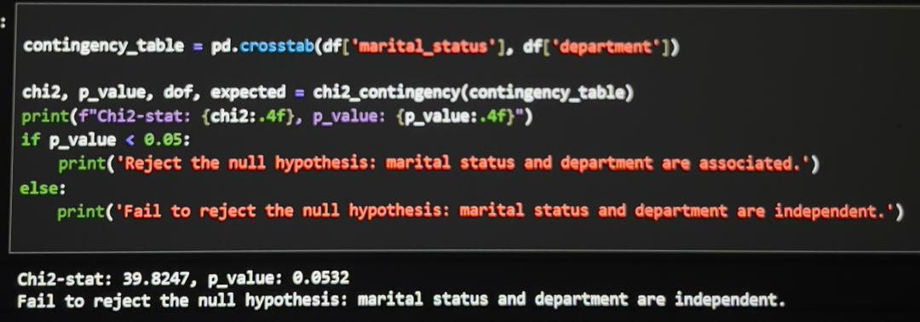
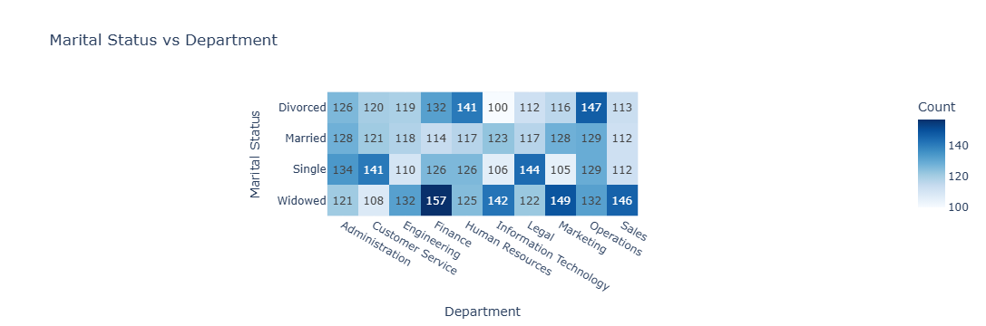
Detailed Interpretation
5.3.1. Understanding the Hypotheses
- Null Hypothesis (H₀): Marital status and department are independent. (The proportion of married, single, divorced, etc., employees is the same across all departments).
- Alternative Hypothesis (H₁): Marital status and department are associated/dependent. (The distribution of marital statuses differs significantly from one department to another).
5.3.2. Key Metric: The P-Value (p_val = 0.0532)
- What it is: The p-value represents the probability of observing the specific distribution of marital statuses across departments that we see in the data, assuming that there is truly no underlying relationship (i.e., the null hypothesis of independence is true).
- The Interpretation: A p-value of 0.0532 means that if marital status and department were completely unrelated, we would see a distribution as uneven as the one in this dataset about 5.32% of the time purely by random chance.
- The Benchmark: Using the standard significance level of 0.05 (5%), our p-value (0.0532) is slightly above this threshold.
Conclusion from P-Value: We fail to reject the null hypothesis. We do not have sufficient statistical evidence to conclude that a meaningful association exists between marital status and department.
3. Key Metric: The Chi-Square Statistic (chi2 = 39.8247)
- The Interpretation: A value of 39.8247, in itself, doesn't have a simple meaning without the degrees of freedom. However, it generates the p-value of 0.0532. The key takeaway is that the difference between observed and expected counts is not large enough to be deemed statistically significant at the standard threshold.

- enough to be deemed statistically significant at the standard threshold.

6. SUMMARY INSIGHTS
This study provided a comprehensive analysis of employee demographics, salary patterns, and departmental distribution at Elite Bank Limited. Several important insights emerged from both descriptive and inferential statistical methods.
- Salary Structure
The organisation operates a clear tier based salary system, with Human Resources (₦710,000), Information Technology (₦640,000), and Marketing (₦630,000) earning the highest average salaries. Lower compensation tiers include Customer Service, Administration, Sales, and Operations. This indicates a strategic emphasis on departments that drive organisational leadership, technology, and visibility.
- Workforce Age Distribution
The majority of employees fall within the 25–32 age group, highlighting a youthful workforce. Representation decreases significantly for older age brackets, especially ages 56–65. This reflects strong youth recruitment but raises concerns about long-term succession and experience retention.
- Education and Salary Relationship
There is a strong positive correlation between educational attainment and salary. Employees with PostDoctoral degrees, PhDs, and MBAs earn substantially higher salaries than those with Bachelor's degrees. This shows that Elite Bank rewards academic advancement and higher professional qualifications.
- Gender and Salary
Statistical testing (t-test) confirms no significant salary difference between male and female employees. This indicates the presence of fair and inclusive pay policies with no gender discrimination.
- Department and Salary Influence
The ANOVA test showed significant differences in salary across departments, confirming that job roles and departmental responsibilities strongly influence employee compensation.
- Marital Status and Department
The Chi-square test revealed no significant relationship between marital status and departmental allocation. This reflects unbiased HR placement practices based solely on job requirements.
- Employee Regional Distribution
Workforce representation is heavily concentrated in the South-East region, with moderate participation from the South-West and North-West. Other regions remain underrepresented, suggesting limited geographical diversity in recruitment.

7: RECOMMENDATIONS
Based on the insights obtained from the analysis, the following recommendations are proposed to enhance organisational efficiency, fairness, and workforce development:
- Expand Recruitment Across Underrepresented Regions
To improve national inclusion, Elite Bank should extend recruitment efforts to the North-East, North-Central, and South-South regions. Partnering with universities and job centres in these zones can help diversify the workforce.
- Strengthen Succession Planning
With a predominantly young workforce, the bank should establish mentorship programs, leadership development pathways, and structured career progression plans to ensure continuity of skills and experience.
- Review Compensation for Lower-Tier Departments
Although salary differences are justified by job roles, periodic reviews should be conducted to ensure that employees in support departments remain motivated. Performance based bonuses and clearer promotion structures can enhance workforce morale.
- Promote and Support Educational Advancement
Since higher qualifications significantly increase salary prospects, the bank should offer tuition assistance, scholarship programs, and professional certification sponsorships to encourage continuous development.
- Sustain Gender Equity Practices
To maintain equal pay and opportunities, the organisation should continue conducting gender equity audits, ensure balanced hiring, and promote female leadership in technical and managerial roles.
- Improve HR Analytics and Data Management
Implementing advanced HR data systems and training staff in analytics tools will support better decision making and help the organisation track employee performance, satisfaction, and retention patterns more effectively.
- Enhance Retention in High-Demand Departments
Departments such as IT, HR, and Marketing should be prioritised for retention strategies, including incentives, flexible working conditions, and structured career advancement.

  - CONCLUSION
- This research successfully analysed the demographic, organisational, and salary patterns within Elite Bank Limited using descriptive and inferential statistical methods. The results reveal a well structured compensation system that rewards advanced education, supports gender fairness, and aligns salary with departmental importance. The dominance of young employees shows strong recruitment efficiency, but also highlights the need for long-term succession strategies.
- Although the organisation demonstrates fairness in compensation and unbiased departmental allocation, regional representation remains uneven, with a heavy concentration of employees from the South-East. Addressing this gap can improve national inclusiveness and organisational diversity.
Overall, the research provides valuable insights that can guide strategic HR planning, enhance workforce development, and support evidence based decision making within the organisation.

